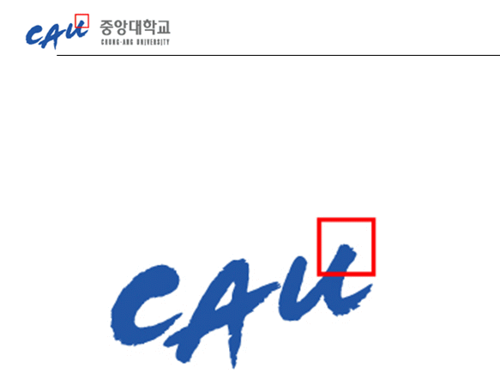**Project Management Report**

|  |  |
| --- | --- |
| **과 목** | **휴먼 ICT 소프트웨어 공학** |
| **팀 구성원** | **20123599 이동직**  **20123421 이현민**  **20146215 지무근**  **20121067 한재현**  **20164891 한윤진** |

**1. Address of github project repository** 2

**2. Project progress history** 3

**3. Experience** 4

**1. Address of github project repository**

[**https://github.com/goofcode/SE_Project**](https://github.com/goofcode/SE_Project)

**2. Project progress history**

First, branch was split. The master branch that stores the finished copy is in one branch, and the actual code work is done first in the dev branch. And each time the function is created under the dev directory, branch was made separately. When the code is finished so that it does not need to be repaired, it merge into basic.

The Software Requirement Specification has been added to the wiki of our github. In the process of adding, a doc branch was created to store image files such as sequence diagrams and use case diagrams.

The issue of github was used every time a task was shared. Whenever the function is completed, commit and pull requests are made, and the team leader manages the requests. Codes authorized by the team leader were stored in the basic branch under the dev.

Below are some examples of branch operations.

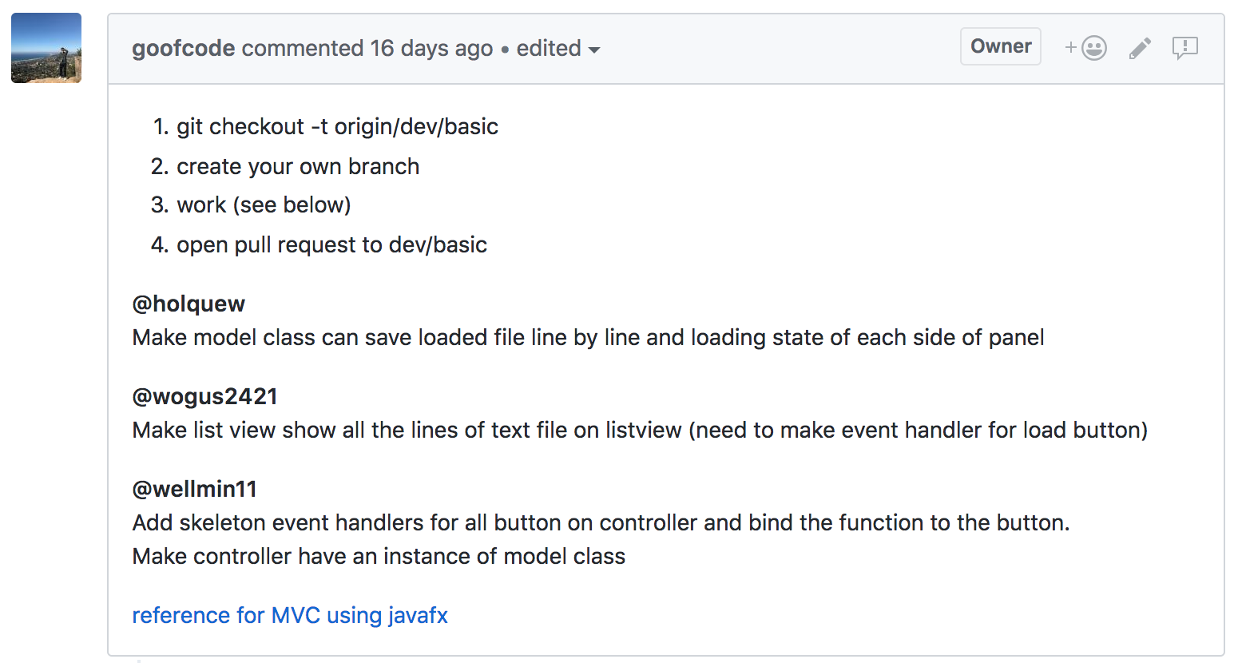

Three branches were created.

1. model class: File load / save function, load state of each panel containing text
2. list view: an operation that displays the text file in the form of a list view
3. controller class: Add all buttons on controller and bind the function to the button

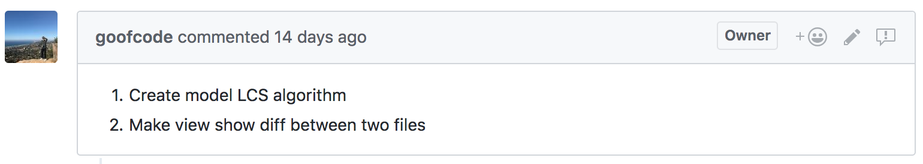

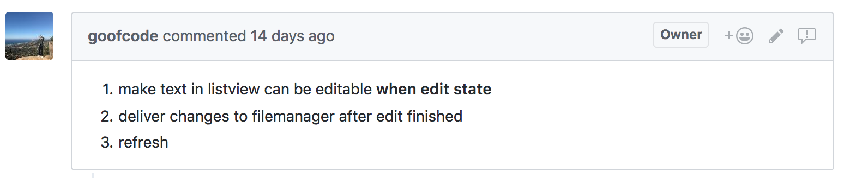

To do the next task, an edit branch was created to modify the text of the diff and panel that deal with the LCS.

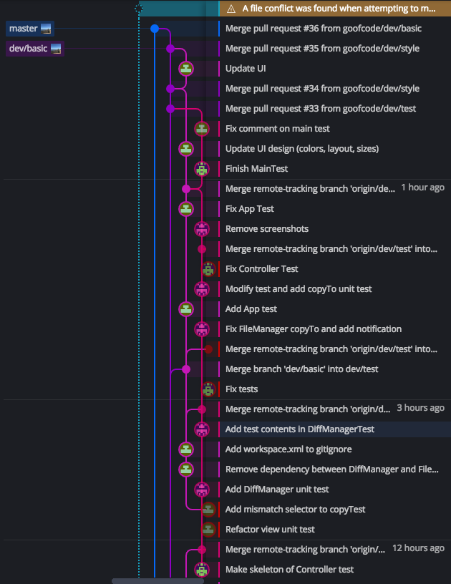

The git gui tool gitKraken is used for this project.

**3. Experience**

* We realized once again the usability of github. The use of the configuration management tool made the maintenance more stable and the progress of the work was smooth, so that the communication between the team members proceeded smoothly.
* When we proceeded with the work, we created a branch for each work, and the division of work became smooth.
* We had some difficulty in understanding the document writing method or the development methodology as a theory. However, in this project, we applied the methodologies in practice and produced the results, so that we could see more concrete ways to apply the theories learned in class and to write documents and diagrams.
* This project was small in size, so it was not too much of a burden to implement, but if we were to carry out a large project, the pre-implementation analysis stage would be very important.